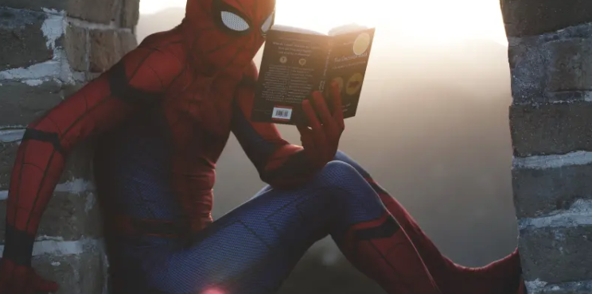

First Grade Reading & Writing (web version)

Every day aim for reading a book of your choice for 20 minutes then choose one or more activities from each collection below:

Starfall and Storyline Online (tech needed)
Check out Starfall! The tab for Learning to Read is great for phonics practice. The tab I'm Reading works for your child to hear stories, read along and animate.
Besides listening to parents read, it's fun for children to hear others read too! Check out Storyline Online to hear famous adults reading great picture books. We recommend Harry the Dirty Dog and Chester's Way.

Writing Week 1
We are out of our regular classroom right now. Make a book that teaches us about your new classroom. Here are a couple of pages from my book. Try to make a new page each day.
This is my dog Lola. She likes to sit by me while I work. Sometimes she interrupts me by barking at a squirrel she sees outside.
These are my LEGOs. I build with them. Yesterday I tried to build tall towers.

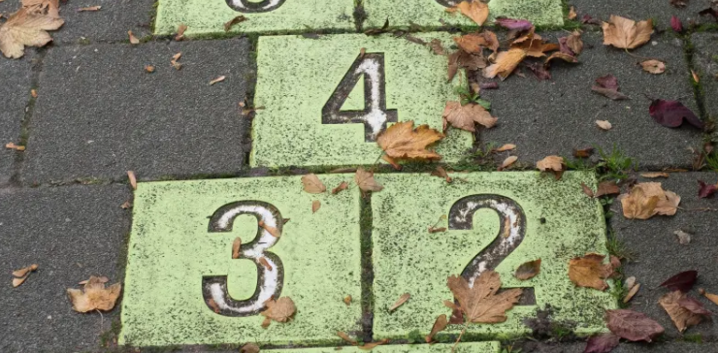

First Grade Math

Math Week 1
- Try a 3 act math task. This week try "Bag-O-Chips" and "The Cookie Monster." You might need scratch paper.
- Try a Counting Collection (See Below). Just let your child count at first, then start asking them questions around if their counting method is efficient or if there is a way to make groups so they can count in different ways.
- Log on to Clever and do Zearn for 20 minutes.
- Watch a video on YouCubed . This week, watch "Believe in Yourself" and talk about how this message can help during challenging math tasks.
- Think of a story problem that goes with the math sentences
12-5=7
&
8 +4=12
Then solve them using two different strategies.

First Grade Science/Social Studies

Geography
Watch the Brainpop (in clever) video titled Continents of the World.
Then, begin exploring South America using Google Earth and Google Earth Voyager.
Question to think about: As you explore this continent, think about what is similar to your community and what is unique and different

Biography
Does your child like learning about famous people from history? Using Clever, check out Brain Pop, Jr. 's biography section to learn more about people like George Washington, Ruby Bridges, and Alexander Graham Bell.

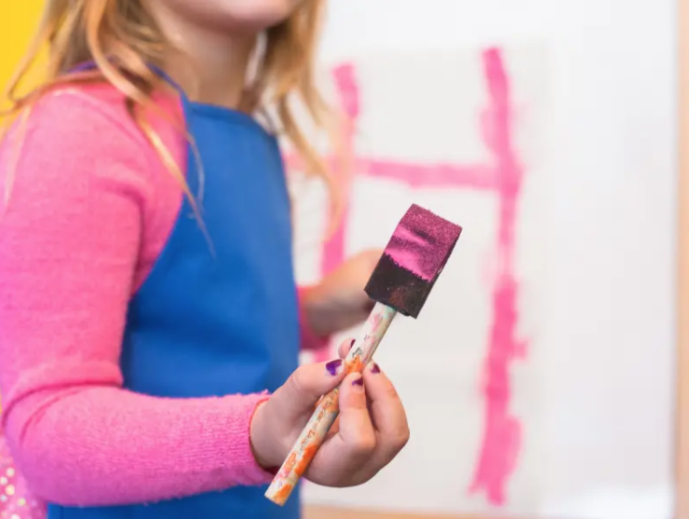

First Grade Enrichment

